Link to the project:

[*https://www.figma.com/design/wxvAtntVX8BoGbIex9BERC/Untitled?node-id=0-1&t=zWgjsgrK5wYGl7Xr-1*](https://www.figma.com/design/wxvAtntVX8BoGbIex9BERC/Untitled?node-id=0-1&t=zWgjsgrK5wYGl7Xr-1)

**Elegant Essential’s Website**

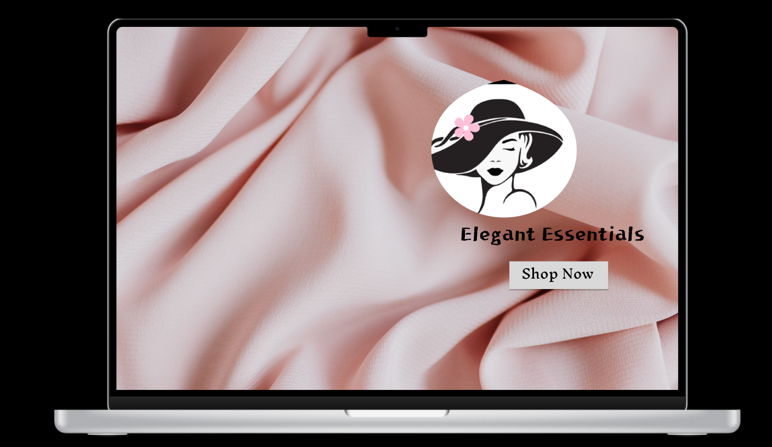



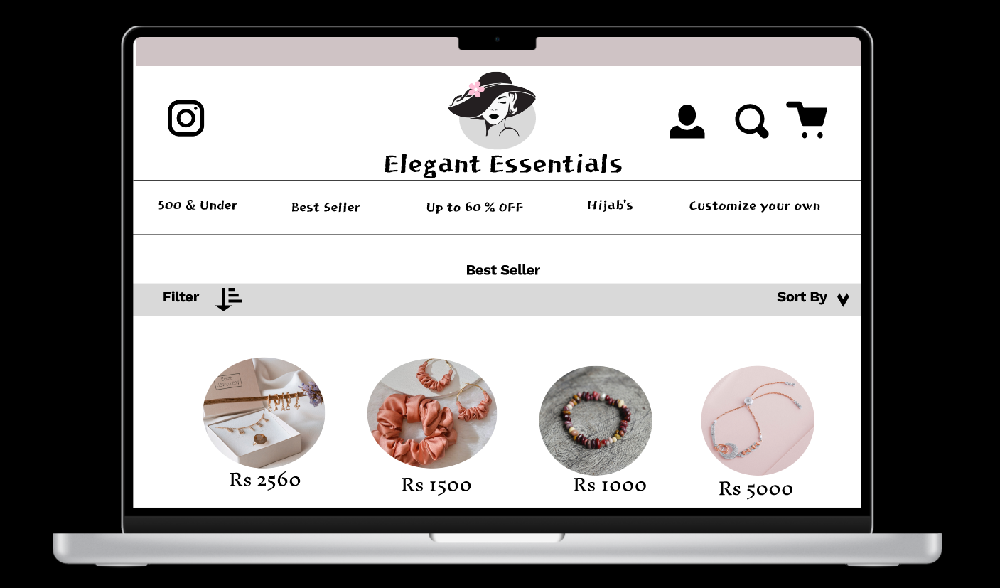

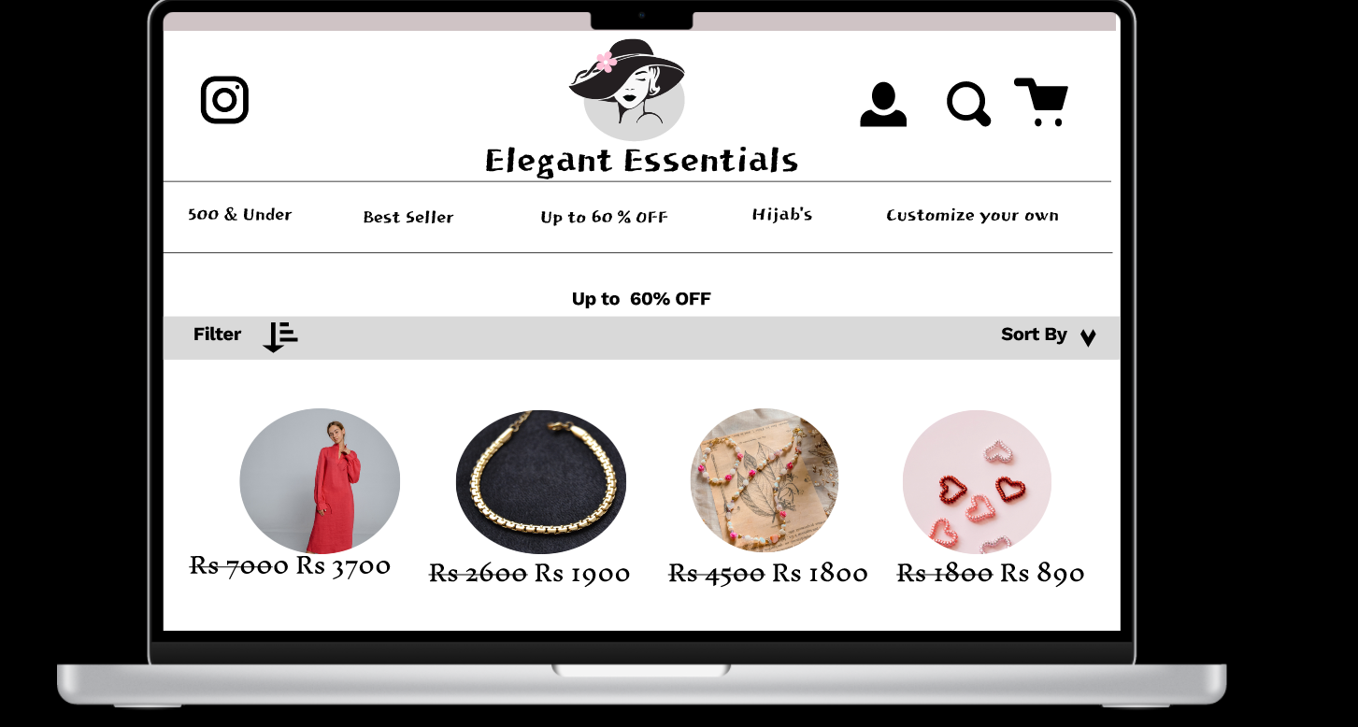

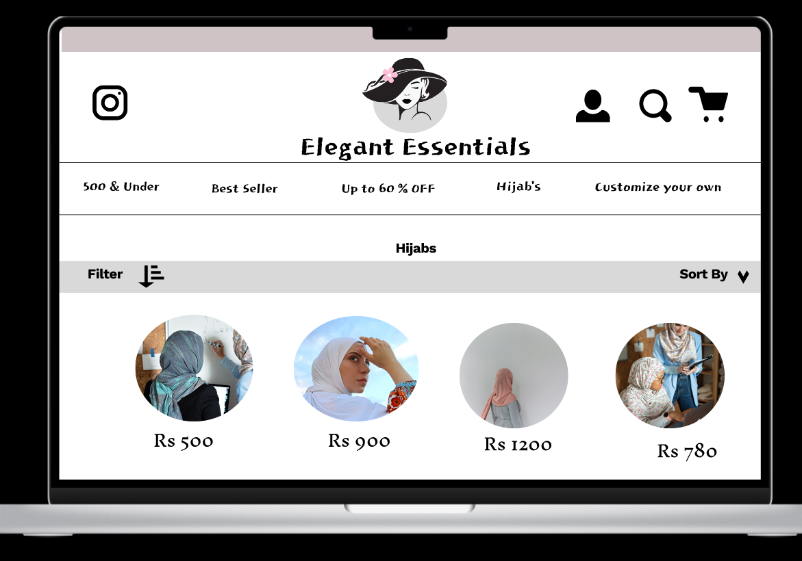

**Prototyping:**

